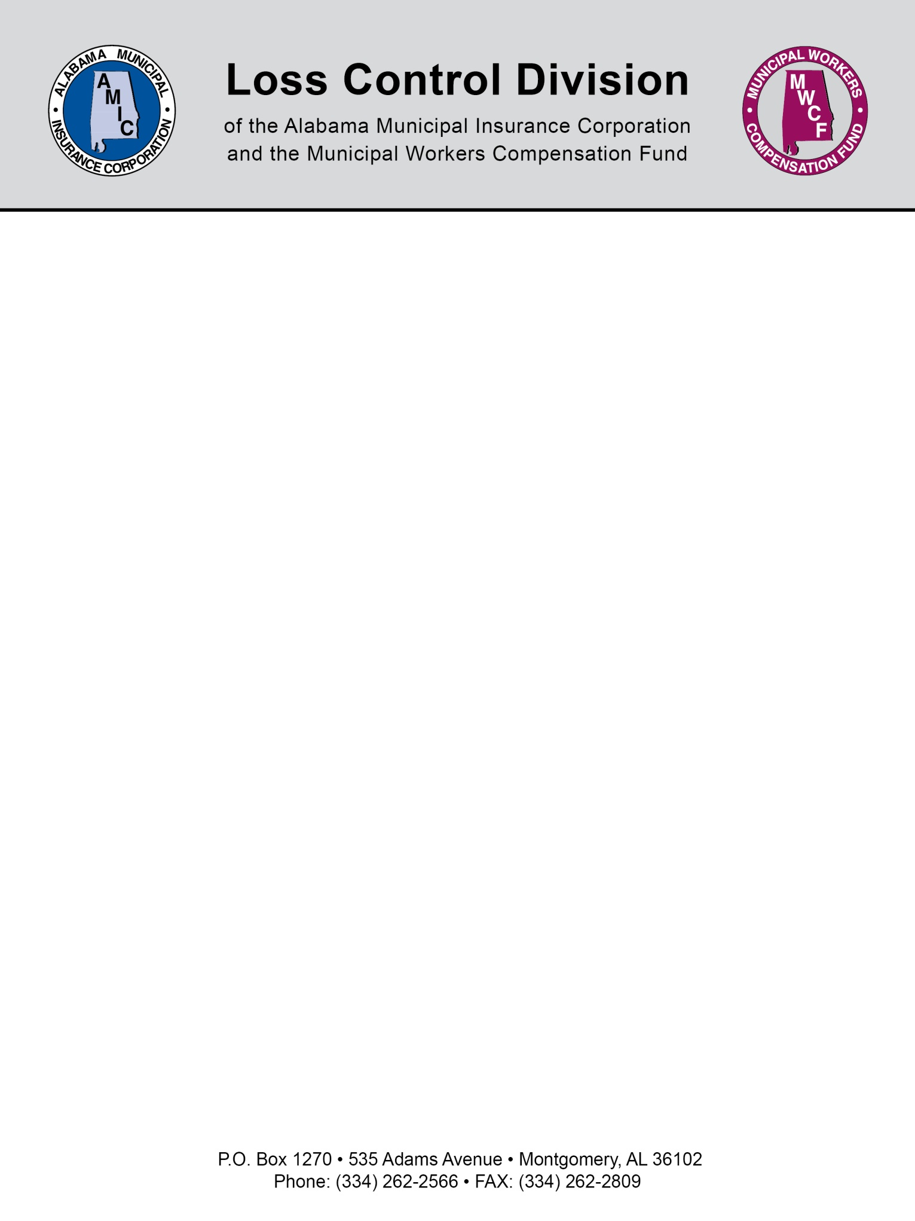

SAMPLE VEHICLE and EQUIPMENT INCIDENT REVIEW PROCEDURE AND ACTIONS PROGRAM

EFFECTIVE (Date)

I. The Safety Committee will use the guidelines listed on the following pages for assessing points any time a (Company) employee is involved in a vehicle or equipment incident.

A preventable incident is defined as any damage to (Company) property, property of others, or bodily injury that could have been prevented by appropriate action on the part of the employee. As a general guideline, all incidents are considered preventable unless the equipment is legally parked or not in motion at the time of contact or where the actions of the employee did not contribute to the incident. In those instances, the incident will be considered non-preventable and no points will be assessed.

2. Points will be totaled for each incident that is determined to be preventable. The Safety Committee will use the following as a guide to recommend action to the department superintendent. Only incidents occurring in the previous 36 months will be used to determine how many preventable incidents the employee has caused. As an example, an employee who had a preventable incident
40 months ago and has not had any preventable incidents since would fall into the First Preventable
Incident category.

3. In the event of a backing damage, passengers may also be assessed points.

POINT SYSTEM GUIDE

FIRST PREVENTABLE INCIDENT

SCORE ACTION RECOMMENDED

3 OR LESS POINTS DOCUMENTED VERBAL COUNSELING

4-I5 POINTS LETTER OF REPRIMAND

16-22 POINTS 8 HOURS SUSPENSION

23 OR MORE POINTS I6 HOURS SUSPENSION

SECOND PREVENTABLE INCIDENT

SCORE ACTION RECOMMENDED

3 POINTS OR LESS LETTER OF REPRIMAND

4-I5 POINTS 8 HOURS SUSPENSION

16-22 POINTS 16 HOURS SUSPENSION

23 OR MORE POINTS 24 OR MORE HOURS SUSPENSION

THIRD PREVENTABLE INCIDENT

SCORE ACTION RECOMMENDED

3 OR LESS POINTS 8 HOURS SUSPENSION

4-I5 POINTS 16 HOURS SUSPENSION

16-22 POINTS 24 HOURS SUSPENSION

23 OR MORE POINTS 32 OR MORE HOURS SUSPENSION

FOURTH PREVENTABLE INCIDENT

FOUR PREVENTABLE INCIDENTS IN A 36 MONTH PERIOD WILL BE CAUSE FOR RECOMMENDATION OF TERMINATION.

*NOTICE*

FAILURE TO REPORT ANY VEHICLE DAMAGE WILL RESULT IN SUSPENSION, DEMOTION OR TERMINATION.

NOTE: This document is not intended to be legal advice. It does not identify all the issues surrounding the particular topic. Public agencies are encouraged to review their procedures with an expert or an attorney who is knowledgeable about the topic. Reliance on this information is at the sole risk of the user.

Revised 1/2014

INCIDENT REVIEW WORKSHEET

NAME DATE DATE OF INCIDENT

TYPE OF INCIDENT POINTS

IMPROPER BACKING +5
TOO FAST FOR CONDITIONS +5
FAILURE TO USE DUE CARE +5
POOR JUDGEMENT +4
STRUCK FIXED OBJECT +4
TRAFFIC SIGNAL VIOLATION +4
FOLLOWING TOO CLOSE +3
IMPROPER LANE CHANGE +3
OTHER +2

PROPERTY DAMAGE

LESS THAN $500
$501 T0 $1,000
MORE THAN $1,000

NONE +0
YES-HOSPITALIZED OVERNIGHT +2
PREVIOUS DRIVING HISTORY CREDIT
YEARS 1 2 3 4 5
-PTS. -1 -2 -3 -4 -5

UTILITY VEHICLE DAMAGE

LESS THAN
$ 500 +0
$ 1,000 +1
$ 2,000 +2
$ 3,000 +3
$ 4,000 +4
$ 5,000 +5
+1 $ 10,000 +6
+2 $ 15,000 +7
+3 $ 20,000 +8
$ 25,000 OR MORE +10

INJURIES

EXTENUATING/MITIGATING CIRCUMSTANCES
AVERAGE -1
SUBSTANTIAL -3

SEATBELTS NOT IN USE +5

INCIDENTS IN PAST 36 MONTHS 1 2 3 4

(MINOR) LESS THAN $5,000  DAMAGE TOTAL | +1 +3 +6 +10
(MAJOR) MORE THAN $5,000  DAMAGE TOTAL | +3 | +6 | +10 | +15

TOTAL POINTS

RECOMMENDED ACTION SAFETY COMMITTEE CHAIRMAN
NOTE: The examples of disciplinary actions contained herein are intended to be guidelines and, as such, do not
preclude more or less severe discipline. For example, whenever severe injury, property damage or negligence occurs, the department superintendent may consider discipline up to and including termination.

